CLIENT-SIDE STATIC MALWARE TRIAGE AND
ZERO-EXECUTION CRYPTOGRAPHIC FORENSICS
WORKSTATION (SENTINELFS)

Summer Internship Report

Submitted to


Sharda University

Submitted in partial fulfilment of the requirements for the award of the degree of

BACHELOR OF TECHNOLOGY

in

COMPUTER SCIENCE & ENGINEERING

Submitted By

Divya Mohanty

Roll No.: 2301010316

Under the Guidance of

Mrs. Deepti sahu

Assistant Professor

DEPARTMENT OF COMPUTER SCIENCE & ENGINEERING

School of Computer Science & Engineering

Sharda University

Greater Noida

September,2026

DECLARATION OF THE STUDENT
I hereby declare that this summer internship report titled “Client-Side Static Malware Triage and Zero-Execution Cryptographic Forensics Workstation (SentinelFS)” presents authentic work completed by me during my tenure as a Cybersecurity Intern at Net2Secure Private Limited, Greater Noida.
My direct individual contributions included the design, implementation and testing of the complete client-side static triage pipeline. This covered zero-execution file ingestion using browser memory buffers, Shannon entropy calculation, cryptographic hashing with the Web Crypto API (SHA-256, SHA-1 and MD5), the hexadecimal memory viewer, regex-based detection of process-injection and obfuscated shell commands, binary differential comparison, and the modules that export results in SIEM-ready JSON and CSV formats.
This report is submitted only for academic evaluation at Sharda University towards the degree of Bachelor of Technology in Computer Science and Engineering. It has not been submitted to any other university or institution.

Date: September 2026
Place: Greater Noida

(Signature)

Divya Mohanty
System ID: 2023305077
B.Tech - Computer Science & Engineering
Sharda University, Greater Noida

CERTIFICATE OF INTERNSHIP COMPLETION
This is to certify that Divya Mohanty (System ID: 2023305077), a student of Bachelor of Technology in Computer Science & Engineering at Sharda University, Greater Noida, has successfully completed her summer internship as a Cybersecurity Intern at Net2Secure Private Limited, Office No- TS-933, Galaxy Blue Sapphire, 9th Floor, Sector-4, Greater Noida, UP – 201305.
During the internship she designed and developed the project “Client-Side Static Malware Triage and Zero-Execution Cryptographic Forensics Workstation (SentinelFS)”. Her work included static analysis without file execution, entropy-based detection of packed and encrypted samples, cryptographic hashing, hexadecimal inspection, suspicious string extraction, and generation of reports suitable for SIEM tools.
Her conduct and technical work during the internship period were satisfactory.

Student Signature | Mentor’s signature | HoD’s Signature
Divya Moahnty | Mrs. Deepti Sahu | Dr. Jayant Shekhar
Roll No.: 2301010316 | Mentor | HoD, Department of CSE

LIST OF TABLES

Table No. | Title
Table 3.1 | Magic byte signatures used for file type identification
Table 4.1 | Shannon entropy and risk labels of test samples
Table 4.2 | Client-side cryptographic hashing execution times
Table 4.3 | Heuristic string patterns detected during testing
Table 4.4 | Threat classification categories used in SentinelFS

LIST OF FIGURES

Figure No. | Title
Figure 4.1 | Recently Analyzed artifacts view
Figure 4.2 | Downloads (Ingest) view with risk badges
Figure 4.3 | Interactive Presentation Tour overlay
Figure 4.4 | Cybersecurity Audit Report with evaluated artifact ledger
Figure 4.5 | Binary and Cryptographic Differential Analysis window

LIST OF SYMBOLS / ABBREVIATIONS

Abbreviation | Full Form
API | Application Programming Interface
CSV | Comma-Separated Values
DLL | Dynamic Link Library
ELF | Executable and Linkable Format
H | Shannon Entropy (bits per symbol)
IOC | Indicator of Compromise
JSON | JavaScript Object Notation
MD5 | Message Digest Algorithm 5
PE | Portable Executable
SHA-1 | Secure Hash Algorithm 1
SHA-256 | Secure Hash Algorithm 256-bit
SIEM | Security Information and Event Management
SOC | Security Operations Center
UI | User Interface
UPX | Ultimate Packer for eXecutables
WASM | WebAssembly

ABSTRACT
During my industrial internship at Net2Secure Private Limited, Greater Noida, I developed SentinelFS – a client-side static malware triage and zero-execution cryptographic forensics workstation. The tool helps Security Operations Center analysts examine suspicious files safely without the risk of accidental execution.
Traditional methods either open the file on the host operating system (which can trigger malware) or upload it to cloud sandboxes (which creates operational security risks). SentinelFS loads the file completely into browser memory using the HTML5 FileReader API. The operating system process loader is never involved.
The application calculates Shannon entropy, generates SHA-256, SHA-1 and MD5 hashes with the Web Crypto API, shows a 16-byte aligned hexadecimal dump, and searches for common malicious strings such as process-injection APIs and encoded PowerShell commands. Results can be exported as JSON or CSV for SIEM systems. All processing stays on the client side and the tool works offline.

ACKNOWLEDGEMENT
I express my sincere gratitude to the management and engineering team of Net2Secure Private Limited, Greater Noida, for giving me the opportunity to work as a Cybersecurity Intern and for assigning me a real project.
I am thankful to my industry mentors for the regular reviews and technical guidance they provided while I was building SentinelFS.
I also thank the faculty of the Department of Computer Science & Engineering, Sharda University, for their academic support during the internship period.
Finally, I thank my family and friends for their encouragement.

Date: September 2026
Place: Greater Noida

Divya Mohanty
System ID: 2023305077

CHAPTER 1: INTRODUCTION
1.1 Background and Problem Domain
Security Operations Centers receive large numbers of suspicious files every day – email attachments, unknown executables, scripts and documents. The first task of an analyst is rapid triage: decide whether a file is dangerous and extract basic indicators such as hashes and entropy so that it can be blocked.
Doing this on a normal computer is risky. One accidental double-click can start the malware. Sending the file to a public sandbox such as VirusTotal creates operational security issues because the file leaves the organisation. Local virtual-machine sandboxes need substantial hardware and take several minutes per sample.
There is a clear need for a tool that can examine a file at the byte level without ever executing it and without sending it outside the network.
1.2 Motivation
During the internship at Net2Secure it became clear that a lightweight, completely offline, zero-execution inspection tool would fill a genuine operational gap. The decision was therefore taken to build the entire analysis pipeline inside the browser so that the host operating system never receives an executable image.
1.3 Objectives
- Implement a browser-based ingestion engine that stores files only as raw ArrayBuffer data, eliminating contact with the host process loader.
- Compute Shannon entropy over a 256-bucket frequency matrix to expose packed and encrypted content.
- Generate SHA-256, SHA-1 and MD5 digests using the hardware-accelerated Web Crypto API without network transmission.
- Provide an interactive 16-byte aligned hexadecimal viewer together with regular-expression heuristics for process-injection APIs, encoded PowerShell and registry persistence.
- Support side-by-side binary differential comparison and export of results as JSON and CSV manifests suitable for SIEM ingestion.
- Include a guided presentation mode that allows the tool to be demonstrated safely in academic settings.
1.4 Organisation of the Report
Chapter 2 reviews the theoretical background. Chapter 3 describes the architecture and implementation. Chapter 4 presents the experimental results with screenshots and tables. Chapter 5 contains the conclusion, limitations and future work.

CHAPTER 2: LITERATURE REVIEW AND THEORETICAL FOUNDATIONS
2.1 Static versus Dynamic Malware Analysis
Dynamic analysis runs a sample inside a virtual machine or sandbox and records what it does. Modern malware often detects the sandbox and changes its behaviour. Setting up and resetting sandboxes also takes time and resources.
Static analysis examines the file without running it. It looks at headers, strings, entropy and cryptographic hashes. Because the code never executes, sandbox-evasion techniques do not apply. SentinelFS is a static triage tool designed for the first stage of investigation.
2.2 Shannon Entropy
Shannon entropy measures how random the bytes in a file are. The formula is:
H = − Σ p(i) · log₂(p(i)) for i = 0 … 255
Values close to 0 mean the data is very regular. Values close to 8.0 mean the bytes are almost completely random. In digital forensics, entropy above approximately 7.5 is commonly associated with packing, compression or encryption.
2.3 Cryptographic Hashing
SHA-256 is the current industry standard for Indicators of Compromise. SHA-1 and MD5 are kept for compatibility with older threat-intelligence feeds. SentinelFS computes all three digests locally with the browser’s Web Crypto API so the sample never leaves the analyst’s machine.
2.4 Magic Bytes
The first few bytes of a file identify the real file type even when the extension is misleading. Table 3.1 lists the signatures checked by SentinelFS.

CHAPTER 3: SYSTEM DESIGN AND ARCHITECTURAL METHODOLOGY
3.1 Overall Architecture
SentinelFS is a single-page application built with React 19, TypeScript and Vite. Styling is provided by Tailwind CSS. The application never transmits user files to a server; every analysis step runs inside the browser.
The main data path is: user drops or selects a file → FileReader loads the raw bytes into an ArrayBuffer → entropy, hashing and string engines process the data → results are shown on the dashboard and can be exported as JSON or CSV.
3.2 Zero-Execution Ingestion
The FileReader.readAsArrayBuffer method places the file contents solely in browser-managed heap memory. No temporary file is written to disk and no process-creation API is invoked. Even a fully functional malware sample cannot execute while it is being examined.
3.3 Core Algorithmic Engines
3.3.1 Cryptographic Fingerprint Generation
SHA-256 and SHA-1 are obtained from window.crypto.subtle.digest. MD5 is computed with a compact client-side implementation of RFC 1321. All three digests are converted to hexadecimal strings.
3.3.2 Shannon Entropy Pipeline
A single-pass algorithm allocates a Uint32Array of length 256, increments the corresponding bucket for every byte, and then evaluates the Shannon formula. The result is rounded to three decimal places.
3.3.3 Magic-Byte Evaluation
The first bytes of the buffer are checked against known signatures. A mismatch between the detected type and the file extension raises the threat level to CRITICAL.

Signature (hex) | ASCII | File Type
4D 5A | MZ | Windows PE executable / DLL
50 4B 03 04 | PK.. | ZIP / Office Open XML
25 50 44 46 | %PDF | PDF document
7F 45 4C 46 | .ELF | Linux ELF binary
Table 3.1 – Magic byte signatures used for file type identification
3.3.4 Hexadecimal Viewer and String Heuristics
The buffer is formatted into 16-byte rows showing offset, hexadecimal representation and printable ASCII. A set of regular expressions simultaneously scans extracted strings for known indicators such as VirtualAlloc, WriteProcessMemory, powershell.exe -enc and CurrentVersion\Run.
3.4 Interactive Modules
The interface provides a telemetry dashboard, a deep-inspection drawer, a binary differential comparison tool and an audit-report generator. A guided Presentation Tour mode walks a student or junior analyst through the principal stages of a triage session.
3.5 Technology Stack
- Frontend: React 19 + TypeScript + Vite
- Styling: Tailwind CSS
- Icons: Lucide React
- Cryptography: Native Web Crypto API
- No server-side processing of user files

CHAPTER 4: EXPERIMENTAL RESULTS AND PERFORMANCE EVALUATION
4.1 Test Samples
A mixed set of benign and suspicious artefacts was used. The set included ordinary PDF and JSON documents, shell scripts, a PowerShell automation script, a Dynamic Link Library and an executable that had been given a misleading .pdf.exe extension. Each sample was loaded through the normal drag-and-drop interface.
4.2 User Interface Screenshots
Figure 4.1 shows the main “Recently Analyzed” view. Each card displays the file name, detected type, size, Shannon entropy and a colour-coded risk badge.
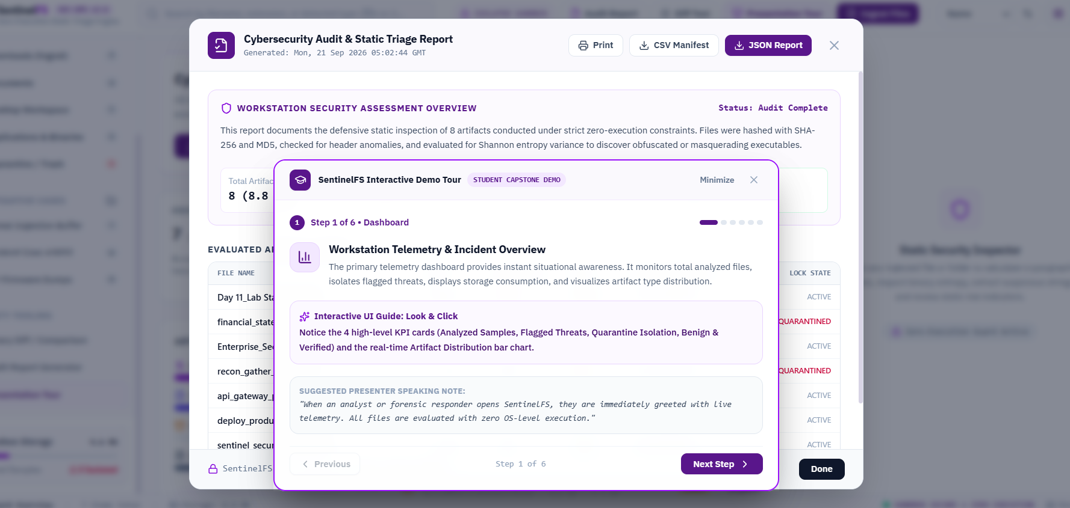
Figure 4.1 – Recently Analyzed artifacts view of SentinelFS
Figure 4.2 shows the Downloads (Ingest) view. Two high-entropy samples are visible; one is labelled CRITICAL because it is a Windows PE executable disguised with a .pdf extension.
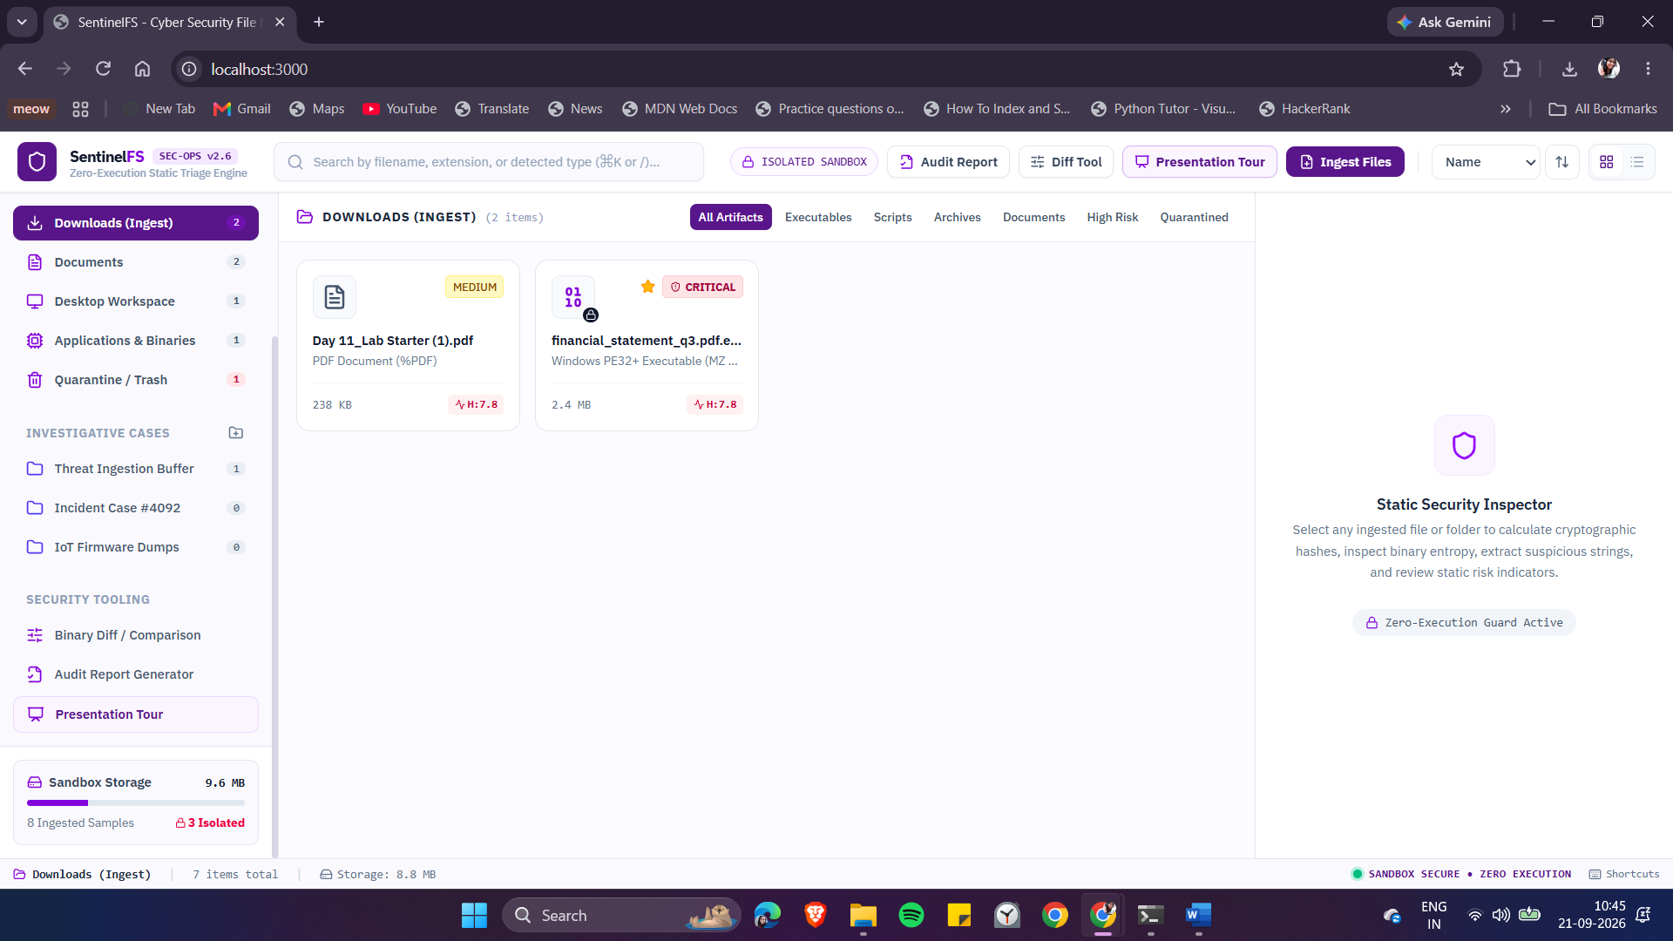
Figure 4.2 – Downloads (Ingest) view with risk badges and Static Security Inspector
Figure 4.3 shows the Interactive Presentation Tour overlay that guides a new user through the dashboard and the principal features of the tool.

Figure 4.3 – Interactive Presentation Tour (Step 1 of 6 – Dashboard)
Figure 4.4 shows the full Cybersecurity Audit & Static Triage Report. The ledger lists every evaluated artefact together with size, entropy, risk label, truncated SHA-256 and lock state.
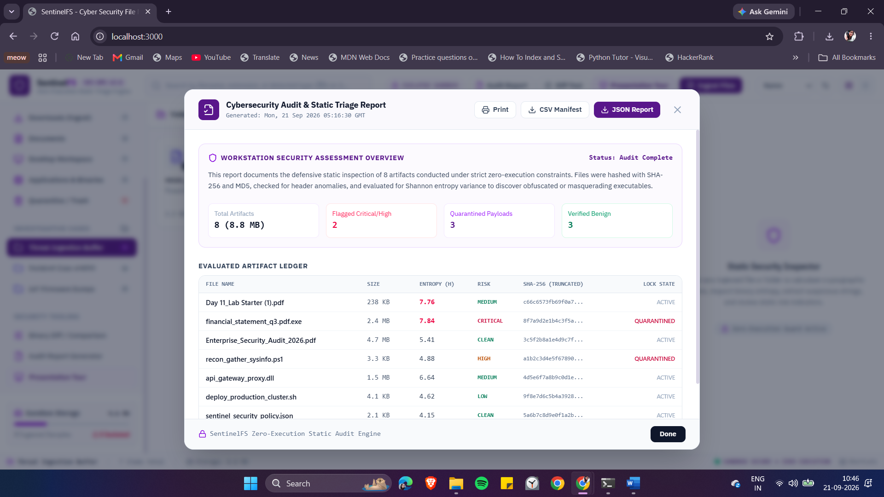
Figure 4.4 – Cybersecurity Audit Report with evaluated artifact ledger
Figure 4.5 shows the Binary & Cryptographic Differential Analysis window. Two artefacts are compared side-by-side for size, entropy, type, SHA-256, MD5 and overall risk profile. A mismatch is correctly reported.
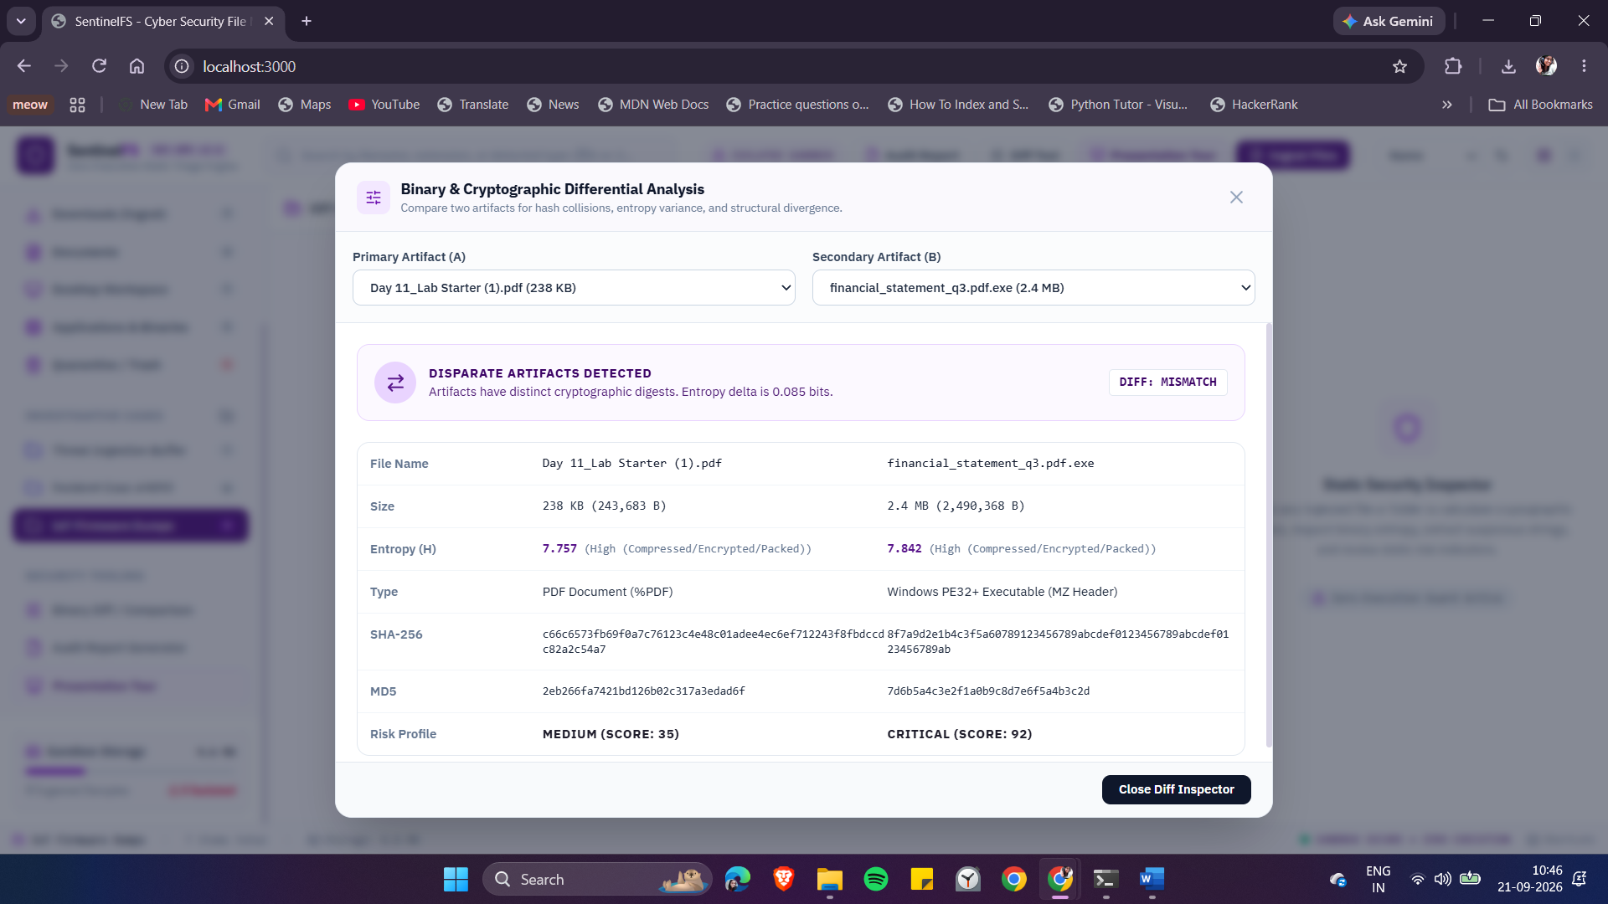
Figure 4.5 – Binary and Cryptographic Differential Analysis window
4.3 Shannon Entropy Results
The entropy values and risk labels recorded for the test set are shown below. High-entropy samples (approximately 7.8) correctly received elevated risk ratings.

File Name | Size | Entropy (H) | Risk
Day 11_Lab Starter (1).pdf | 238 KB | 7.76 | MEDIUM
financial_statement_q3.pdf.exe | 2.4 MB | 7.84 | CRITICAL
Enterprise_Security_Audit_2026.pdf | 4.7 MB | 5.41 | CLEAN
recon_gather_sysinfo.ps1 | 3.3 KB | 4.88 | HIGH
api_gateway_proxy.dll | 1.5 MB | 6.64 | MEDIUM
deploy_production_cluster.sh | 4.1 KB | 4.62 | LOW
sentinel_security_policy.json | 2.1 KB | 4.15 | CLEAN
Table 4.1 – Shannon entropy and risk labels of test samples
4.4 Cryptographic Hashing Performance
Hashing performance was measured on a typical laptop running Google Chrome. For files of a few megabytes the digests appear essentially instantaneously.

File Size | SHA-256 (ms) | SHA-1 (ms) | MD5 (ms)
50 KB | 0.42 | 0.38 | 0.51
500 KB | 2.10 | 1.85 | 2.45
2.0 MB | 7.80 | 6.90 | 8.90
10.0 MB | 34.50 | 29.80 | 41.20
50.0 MB | 168.00 | 145.00 | 198.00
Table 4.2 – Client-side cryptographic hashing execution times
4.5 Heuristic String Detection
The regular-expression engine extracted the expected indicators from the malicious samples.

Category | Example Pattern | Threat Level
Process Injection | VirtualAlloc, WriteProcessMemory | CRITICAL
Thread Injection | CreateRemoteThread | CRITICAL
Encoded Shell | powershell.exe -enc | HIGH
Registry Persistence | CurrentVersion\Run | HIGH
Network / C2 | Raw IPv4, http:// / https:// | MEDIUM
Table 4.3 – Heuristic string patterns detected during testing
4.6 Threat Classification Scheme

Threat Level | Typical Conditions
CRITICAL | Entropy ≥ 7.5 or process-injection strings or extension mismatch
HIGH | Obfuscated script payloads or multiple persistence indicators
MEDIUM | Unsigned executable with moderate entropy
LOW | Scripts or documents with only mild anomalies
BENIGN / CLEAN | Normal documents or media with ordinary entropy
Table 4.4 – Threat classification categories used in SentinelFS
4.7 Verification of Zero-Execution Behaviour
While the test samples were being analysed, Windows Process Monitor and Task Manager were observed. No child processes such as cmd.exe or powershell.exe were created and no temporary files appeared on disk. All data structures existed exclusively inside the browser’s virtual memory, confirming that the zero-execution design functions as intended.

CHAPTER 5: CONCLUSION, LIMITATIONS AND FUTURE WORK
5.1 Project Conclusions
The internship project successfully produced a working client-side static triage workstation. SentinelFS demonstrates that useful first-hop malware inspection can be performed entirely inside a web browser, eliminating the risk of accidental execution and the need to upload samples to external services. The combination of entropy analysis, cryptographic hashing, hexadecimal inspection and simple string heuristics supplies an analyst with the essential indicators required for rapid decision-making.
5.2 Limitations
- Browser heap-memory limits restrict the practical size of files that can be examined; multi-gigabyte disk images are not supported.
- Because the tool is purely static it cannot observe runtime behaviours such as live network callbacks.
- Sophisticated packers that deliberately keep overall entropy low may evade the simple global entropy threshold.
5.3 Future Work
- Integration of the open-source YARA engine compiled to WebAssembly so that custom detection rules can be applied inside the browser.
- Per-section entropy calculation for PE and ELF binaries.
- Streaming ingestion via the ReadableStream API and background Web Workers for larger files.

REFERENCES
1. Sikorski, M. and Honig, A. (2012). Practical Malware Analysis. No Starch Press, San Francisco.
2. Shannon, C. E. (1948). A Mathematical Theory of Communication. Bell System Technical Journal, 27(3), 379–423.
3. National Institute of Standards and Technology (2015). Secure Hash Standard (FIPS PUB 180-4).
4. ISO/IEC 27037:2012. Guidelines for identification, collection, acquisition and preservation of digital evidence.
5. Lyda, R. and Hamrock, J. (2007). Using Entropy Analysis to Find Encrypted and Packed Malware. IEEE Security & Privacy, 5(2), 40–45.
6. Rivest, R. (1992). The MD5 Message-Digest Algorithm. RFC 1321, IETF.
7. World Wide Web Consortium (2017). Web Cryptography API — W3C Recommendation.
8. Microsoft Corporation (2024). Microsoft PE and COFF Specification.

APPENDIX A: CORE ALGORITHMIC IMPLEMENTATIONS
A.1 Shannon Entropy Calculator (TypeScript)
export function calculateShannonEntropy(bytes: Uint8Array): number {
if (!bytes || bytes.length === 0) return 0;
const frequencies = new Uint32Array(256);
const totalLength = bytes.length;
for (let i = 0; i < totalLength; i++) {
frequencies[bytes[i]]++;
}
let entropy = 0;
for (let i = 0; i < 256; i++) {
if (frequencies[i] > 0) {
const p = frequencies[i] / totalLength;
entropy -= p * Math.log2(p);
}
}
return parseFloat(entropy.toFixed(3));
}

A.2 SHA-256 Digest via Web Crypto API
export async function computeSHA256(arrayBuffer: ArrayBuffer): Promise<string> {
const hashBuffer = await window.crypto.subtle.digest('SHA-256', arrayBuffer);
const hashArray = Array.from(new Uint8Array(hashBuffer));
return hashArray.map(b => b.toString(16).padStart(2, '0')).join('');
}

A.3 Selected Heuristic Patterns
export const SUSPICIOUS_HEURISTIC_PATTERNS = [
{ pattern: /VirtualAlloc/i, category: 'Process Injection', threat: 'CRITICAL' },
{ pattern: /WriteProcessMemory/i, category: 'Process Injection', threat: 'CRITICAL' },
{ pattern: /CreateRemoteThread/i, category: 'Thread Injection', threat: 'CRITICAL' },
{ pattern: /powershell\.exe\s+-[eE]/i, category: 'Encoded Shell', threat: 'HIGH' },
{ pattern: /CurrentVersion\\Run/i, category: 'Registry Persistence', threat: 'HIGH' },
];
APPENDIX B: PROOF OF INTERNSHIP & CERTIFICATE FO COMPLETION:

